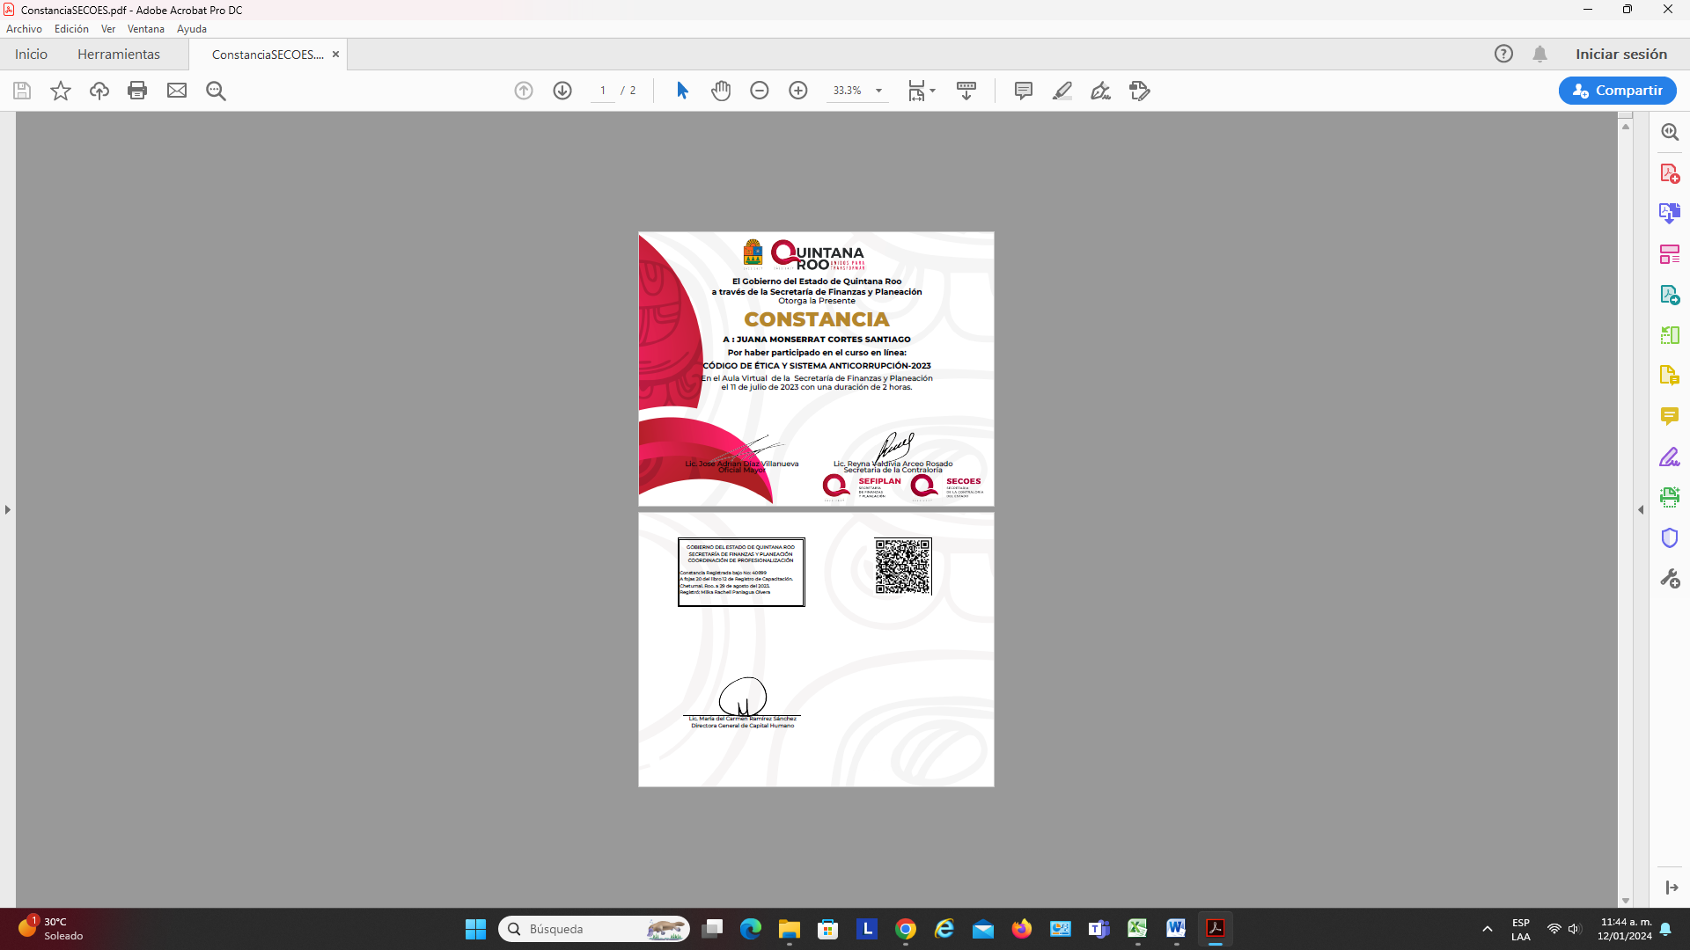

|  |  |
| --- | --- |
|  | NOMBRE |
| 1 | Angel Humberto Briceã‘O Chuc |
| 2 | Acxer Roberto Zamora Sosa |
| 3 | Ada Nely Luna Cardenas |
| 4 | Adã¡N Gordillo Arroyo |
| 5 | Ady Lucely Peraza Caamal |
| 6 | Alejandro Lozano Cruz |
| 7 | Alejandro Rosado Centurion |
| 8 | Alejandro Salgado Perez |
| 9 | Alfredo Edmundo Melendez Uc |
| 10 | Alondra Concepcion Lopez Astudillo |
| 11 | Alvaro Jesãºs Canche Moo |
| 12 | Amã©Rica Citlaly Coral Albornoz |
| 13 | Ana Luisa Haw Kuc |
| 14 | Ana Marã­a Zarate SÃ¡Nchez |
| 15 | Ana Patricia Peraza Muã‘Oz |
| 16 | Anahi.Mat88@Gmail.Com |
| 17 | Anastacio Montero Morales |
| 18 | Angel Flporentino Gonzalez Buenfil |
| 19 | Angel Hernando Zetina Lopez |
| 20 | Angel Javier Coba Chan |
| 21 | Angelica Yam Pool |
| 22 | Aridai De Los Angeles |
| 23 | Aries Valerio Palma Santos |
| 24 | Armin Arcangel Menzoza Martinez |
| 25 | Arnold Rivas Maldonado |
| 26 | Arturo Antonio Arceo Alayola |
| 27 | Azucena Berenice Enriquez Torres |
| 28 | Benjamin Chulin Chuc |
| 29 | Brandon Balderas Gonzalez |
| 30 | Brenda Betzabe Torres Valencia |
| 31 | Brianda Escalona Noh |
| 32 | Bruna Domitila Ramirez Leyva |
| 33 | Bryan Emanuel May Poot |
| 34 | Candido Solis Torres |
| 35 | Carlos Alberto Selem Salinas |
| 36 | Carlos Amaro Torres |
| 37 | Carlos Miguel Santiago Delgado |
| 38 | Carlos Miguel Schultz Lee |
| 39 | Carmen Guadalupe Rivas Gio |
| 40 | Cecilia Guadalupe Paredes Pech |
| 41 | Cesar Ortuã±O Cruz |
| 42 | Chan Pool Carlos Miguel |
| 43 | Christian Cortes Zamudio |
| 44 | Clicerio Norberto Mora Chuc |
| 45 | Coral Salas Gomez |
| 46 | Cristina Guadalupe Sandoval Gã“Mez |
| 47 | Dafne Karime Orozco Angelino |
| 48 | Daniel Gomez Chan |
| 49 | David Enrique Koh Jimenez |
| 50 | David Israe Sosa Alonso |
| 51 | Donaciana Puc Chan |
| 52 | Dora Yaneth Villaseca Reyes |
| 53 | Dulce Amira Acosta Campos |
| 54 | Eder Aguilar Mollinedo |
| 55 | Edin Mauricio Aguilar Flores |
| 56 | Eduardo Castro Pã‰Rez |
| 57 | Eduardo Jose Cisneros Paredes |
| 58 | Eduin Tonatiu Zollner SÃ¡Nchez |
| 59 | Edwin Alejandro Cetina Contreras |
| 60 | Efrain Barrios Vazquez |
| 61 | Eleuterio Noh Cauich |
| 62 | Emilio Atilano Ruiz Romero |
| 63 | Emmanuel Benito Cabrera PÃ©Rez |
| 64 | Esmeralda Amaya Sanchez |
| 65 | Evelia Hernã¡Ndez Viera |
| 66 | FÃ¡Tima Del Rosario Ku Meneses |
| 67 | Fabiola Fidelia Briceã±O Magaã±A |
| 68 | Fanny Del Rocio LÃ³Pez Romero |
| 69 | Fany Del Carmen Lara Ceballos |
| 70 | Fidel Vicente Canto Villanueva |
| 71 | Florencio Balam Canche |
| 72 | Francisco Alfonso Junco Diaz |
| 73 | Francisco Guillermo Pasarã³N Salgado |
| 74 | Francisco Jimã©Nez Escobar |
| 75 | Gaver Antonio Soberanis Gonzalez |
| 76 | Genny Ariandy Iste Cau |
| 77 | Geny Esther Piã‘A Mul |
| 78 | Georgina Chi Keb |
| 79 | Gerardo Enrique Canul Ruiz |
| 80 | Gerardo Maglah Cab |
| 81 | Gerardo Rafael Briceã±O Pinzã³N |
| 82 | Gonzalo Gildardo Naal Hau |
| 83 | Gregoria Paredes Castillo |
| 84 | Guadalupe Lanz Itzincab |
| 85 | Guillermina Rivera Chã¡Vez |
| 86 | Guillermo Abraham Koh Can |
| 87 | Gustavo Cruz Balam |
| 88 | Gustavo Escobedo Canales |
| 89 | Haydeã‰ Badinerie Rojas HernãNdez |
| 90 | Hector Alfonso Castro Maldonado |
| 91 | Hilary Alejandra Viana Ramirez |
| 92 | Hilda Rosa Maas Tun |
| 93 | Huri Isabel Cruz Anguiano |
| 94 | Ileana Del Rocã­o Sauri Palma |
| 95 | Ingrid Anahi Xool Mis |
| 96 | Irving Oswaldo Hernandez Cervera |
| 97 | Isaac Jimenez Lazaro |
| 98 | Issalilet Aguilar |
| 99 | Jamy Ricardo Maldonado Quiã±Ones |
| 100 | Javier Raul Castillo Canto |
| 101 | Jaziel Antonio Uicab Ferral |
| 102 | Jesica Del Carmen Capistran Santos |
| 103 | Jessica SofãA Rosado HernãNdez |
| 104 | Jesus Benitez Castillo |
| 105 | Jesus Filomeno Gongora Balan |
| 106 | Jhessica Nayeli Arenas Torruco |
| 107 | Joaquin Ismael Fernandez Aragon |
| 108 | Jonathan Thomã‰ Molina |
| 109 | Jorge Alberto Morales Tafolla |
| 110 | Jorge DÃ­az SÃ¡Nchez |
| 111 | Jorge Luis Narez Alvarez |
| 112 | Jorge Miguel Uicab Oy |
| 113 | Josã© Alfredo Hernã¡Ndez Del Valle |
| 114 | Josã© Carlos Ruiz Chi |
| 115 | Jose Claudio Soberano Soberano |
| 116 | Jose Feliciano Canul Pacheco |
| 117 | Jose Filiberto Sosa Varguez |
| 118 | Jose Jacinto Ruiz Mena |
| 119 | Jose Luis Magaã‘A Sanchez |
| 120 | Jose Rosendo Caamal Chay |
| 121 | Jose Vidal Gamez Muã‘Oz |
| 122 | Josefa Dominguez Diaz |
| 123 | Josefa Solis Cruz |
| 124 | Josefina Concepcion Gonzalez Castillo |
| 125 | Josimar Alpuche Perez |
| 126 | Juan Alberto Garcia Geronimo |
| 127 | Juana Catalina LÃ³Pez Baeza |
| 128 | Juana Monserrat Cortes Santiago |
| 129 | Julia Alejandra Beltrã¡N Hernã¡Ndez |
| 130 | Julia Anaid Noh Pedraza |
| 131 | Karen Janette Cahuich Canche |
| 132 | Karla Monica Vargas Padrã“N |
| 133 | Leidy Laura Dã­az Alfaro |
| 134 | Leonado A. Jimenez Maya |
| 135 | Leydi Del Pilar Ulloa Ramirez |
| 136 | Leydi Narvã¡Ez Salas |
| 137 | Leydy Marlene Solis Jimenez |
| 138 | Lidia Esther Hoil Poot |
| 139 | Ligia Concepciã“N De La Rosa Quintal |
| 140 | Lilia Hernã¡Ndez Hernã¡Ndez |
| 141 | Lilian Gioana Montalvo Pool |
| 142 | Lina Gabriela Gutiã©Rrez Torres |
| 143 | Lorena Yasmin Arana Arguells |
| 144 | Lorenzo Manuel Loria Fernandez |
| 145 | Lourdes Del Rosario PÃ©Rez Zavala |
| 146 | Luis Angel Hernã¡Ndez Akã© |
| 147 | Luis Miguel MÃ©Ndez Hernã¡Ndez |
| 148 | Luis Roberto Salazar Oliva |
| 149 | Luz Celeste Canche Sanchez |
| 150 | Luz Payricia Saury Galue |
| 151 | Manuel Jesãºs Cabaã±As May |
| 152 | Marã­a Angã©Lica Mora Platero |
| 153 | Marã­a De FÃ¡Tima Gongora Pech |
| 154 | Marã­a Del Carmen Gasca Arrieta |
| 155 | Marã­a Guadalupe Merino Barragã¡N |
| 156 | Marã­a Isabel Javier Castillo |
| 157 | Marã­a Rosy Chi Balam |
| 158 | Maria Alicia Quiroga Calderon |
| 159 | Maria Angelica Trejo Figueroa |
| 160 | Maria Del Socorro Caamal Cano |
| 161 | Maria Goretti Tun Chan |
| 162 | Maria Iliana Euan Mex |
| 163 | Maria Jose Gonzalez Mendoza |
| 164 | Maria Selene Chable Pech |
| 165 | Mariana SÃ¡Nchez De La Barquera Escamilla |
| 166 | Marina De Los Angeles Abam Dominguez |
| 167 | Mario Humberto Baez Sosa |
| 168 | Marisol Meza PÃ©Rez |
| 169 | Marlon Fernando Canul Leon |
| 170 | Martha Andrea Avila Avila |
| 171 | Martha Cruz Hernande |
| 172 | Martha Patricia Dominguez Zepeda |
| 173 | Martha Patricia Kuyoc Caamal |
| 174 | Martha Paulina Chavez Barajas |
| 175 | Melvis Del Carmen Cortazar SãNchez |
| 176 | Mercedes Fuentes Castellanos |
| 177 | Mercedes Rosario Mis Reyes |
| 178 | Miguel Adrian Flota Ix |
| 179 | Miguel Angel Arceo Rodrã­guez |
| 180 | Miguel Angel Galera Chin |
| 181 | Mireya Concepcion Solis Cima |
| 182 | Mirla Leticia Hau Cupul |
| 183 | Mirna Rosalba Kauil May |
| 184 | Moisã©S Palomino Cardeã±A |
| 185 | Monica Abril De La Mora Alpuche |
| 186 | Nahim Antonio Amar Villanueva |
| 187 | Nain Eliasim Pech Pech |
| 188 | Nibardo De Jesãºs Cervantes Chan |
| 189 | Norma Alicia Chan Miranda |
| 190 | Norma Aurora Hau Gonzã¡Lez |
| 191 | Olga De FãTima SãEnz Tzek |
| 192 | Omar Antonio Badillo Sanchez |
| 193 | Pablo Alfredo Vazquez Cocom |
| 194 | Patricia Karina Maas Tun |
| 195 | Pedro Alberto Jimã©Nez Tamayo |
| 196 | Pedro Edgardo Vegobi Chacon |
| 197 | Pedro Pablo Lopez Canul |
| 198 | Rafael Castellanos Aburto |
| 199 | Rafael Pacheco Sulub |
| 200 | Raul Eliezer Martin Cool |
| 201 | Renã© Alejandro Rodrã­guez Lee |
| 202 | Ricardo Vazquez Nuã‘Ez |
| 203 | Richard Josã© Martã­n Moguel |
| 204 | Rigoberto Xool Ek |
| 205 | Rita Mireya Avilã©Z Maya |
| 206 | Roberto Barajas Rojas |
| 207 | Rogelio ÃNgel Forbes Hernã¡Ndez |
| 208 | Rosa Camacho |
| 209 | Rosa Isela RodrãGuez Salazar |
| 210 | Rosario Puc Medina |
| 211 | Rossana Berenice Silveira Uch |
| 212 | Ruth Alejandra Cardeã±A Rodrã­guez |
| 213 | Sagrario De Jesãºs Kumul Ceme |
| 214 | Sahirely Anahi Matos Torres |
| 215 | Said Yamel Navarrete Delgado |
| 216 | Salma Sarai Ahinoam Pech Pech |
| 217 | Salvador Granados GarcãA |
| 218 | Sandra Yazmin Aguilera Lopez |
| 219 | Senen Ranfery Santiago Torres |
| 220 | Sergio Ivan Ku Gomez |
| 221 | Sergio Miguel RÃ­os Villasis |
| 222 | Silvia Beatriz Santos Cã¡Mara |
| 223 | Silvia Chan Tuz |
| 224 | Silvia Guadalupe Ek Chan |
| 225 | Silvia Ramily Cantã© Cruz |
| 226 | Sirius Shantal Tenorio Cardona |
| 227 | Susana Del Rosario Lee Rejon |
| 228 | Tania Jonahandi Salazar Vargas |
| 229 | Tatiana Ninette Ordoã‘Ez De La Riva |
| 230 | Teresa De Jesãºs Piã±A Muã±Oz |
| 231 | Teresa Guadalupe Luna Sanchez |
| 232 | TERESITA DE Jesãšs QUEN TUCUCH |
| 233 | Tirza Margarita Peraza Caamal |
| 234 | Uriel Alejandro Contreras Soacatl |
| 235 | Victor Andres Ancona Torres |
| 236 | Victor Cruz Garcã­a |
| 237 | Victor Hugo Delgado Bibiano |
| 238 | Virginia Vazquez Torres |
| 239 | Wendolin Adame Negrete |
| 240 | Wiliam Josã© Cruz Mena |
| 241 | Xquenda Yaremi Lã“Pez Tamayo |
| 242 | Yadira Paola Mendoza May |
| 243 | Yamile Natividad PÃ©Rez Gonzã¡Lez |
| 244 | Yarisol Guadalupe Garcia |
| 245 | Yesli Fabiola Garcia Cano |
| 246 | Yolanda Uch Noh |
| 247 | Yoni Herbert Cab Ku |
| 248 | Zoram Josue Villalobos Casas |

Total de Hombres 122

Total de Mujeres 125